Report of John Washer device
Analysis of the Washer device shows that it is running Windows XP (figure 4). System time zone informa tion discovered through the Windows Registry Viewer shows the device was set to Eastern Standard Time, which aligns with filesystem timestamps and log artifacts (figure 5). Multiple local user accounts were identified, many of which appear themed or test-like, suggesting the device may have been used for experimentation, shared use, or intentional obfuscation (figure 3).
The system contains several administrator-level accounts with significant activity, including Billy Bob Brubeck and The Wolf, each with 22 logins, as well as Mr Smee and Captain Hook with 21 logins each (figure 1). Additional accounts such as the built-in Administrator and Artimus were either minimally used or unused(figure 2). No single primary user could be determined, as multiple accounts show nearly identical usage patterns. Searches conducted on the system point that the user displayed interest in the James Patterson novel The Wolf, and these searches cluster around the same timeframe as other activity on the device (figure 4).
Several artifacts on the Washer device establish connections to Wes Mantooth. A Microsoft Word document recovered from the system was authored by Wes Mantooth and appears to have been created for testing dtSearch functionality, suggesting technical interaction between the two users (figure 5). Additionally, a deleted email conversation, titled “What’s Up in D Town,” was found on the Washer device, and a matching copy exists on the Mantooth device (figure 6 – 7). This confirms communication and shows messaging between John Washer and Wes Mantooth. An image identified as John Washer’s to-do list contains a reference to Wes Mantooth, further corroborating direct interaction (figure 8).

Taken together, the evidence from the Washer device demonstrates multiple administrator-level users with themed account names, consistent system configuration, and direct communication with Wes Mantooth. These artifacts collectively establish a clear connection between the two individuals and support a unified narrative linking both devices within the broader investigative context. The combination of documents, email correspondence, and task-related artifacts provides a timeline and context that supports the story of interaction between Washer and Mantooth.

Figure 1-3 information on different users
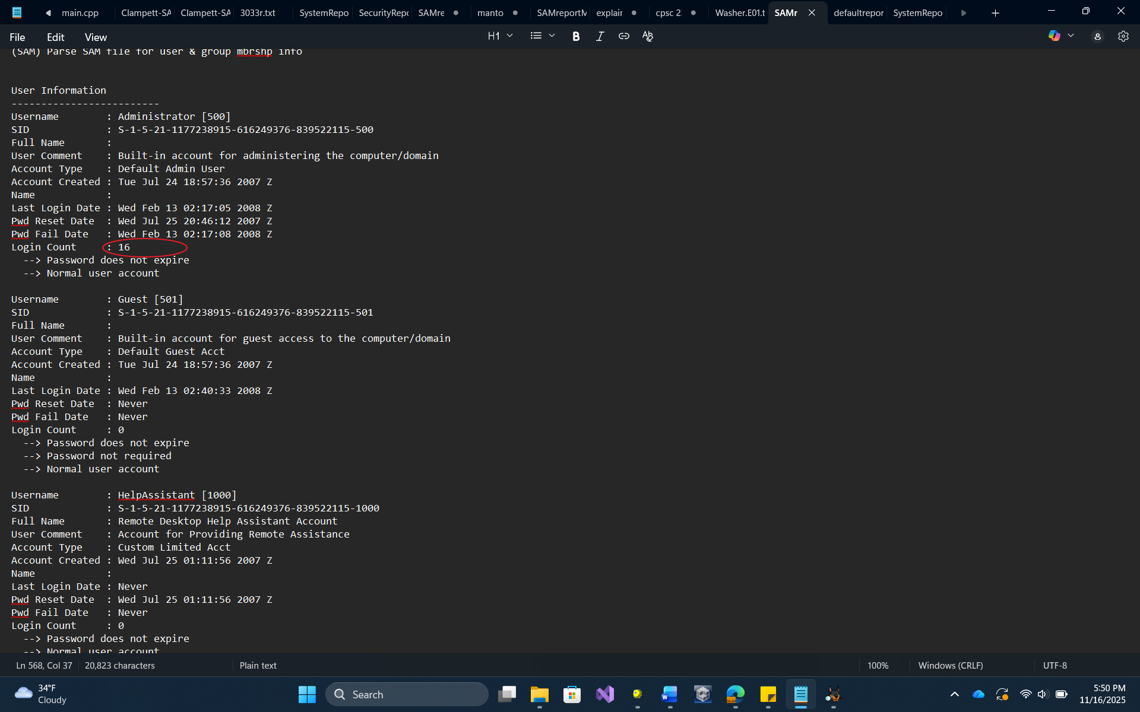
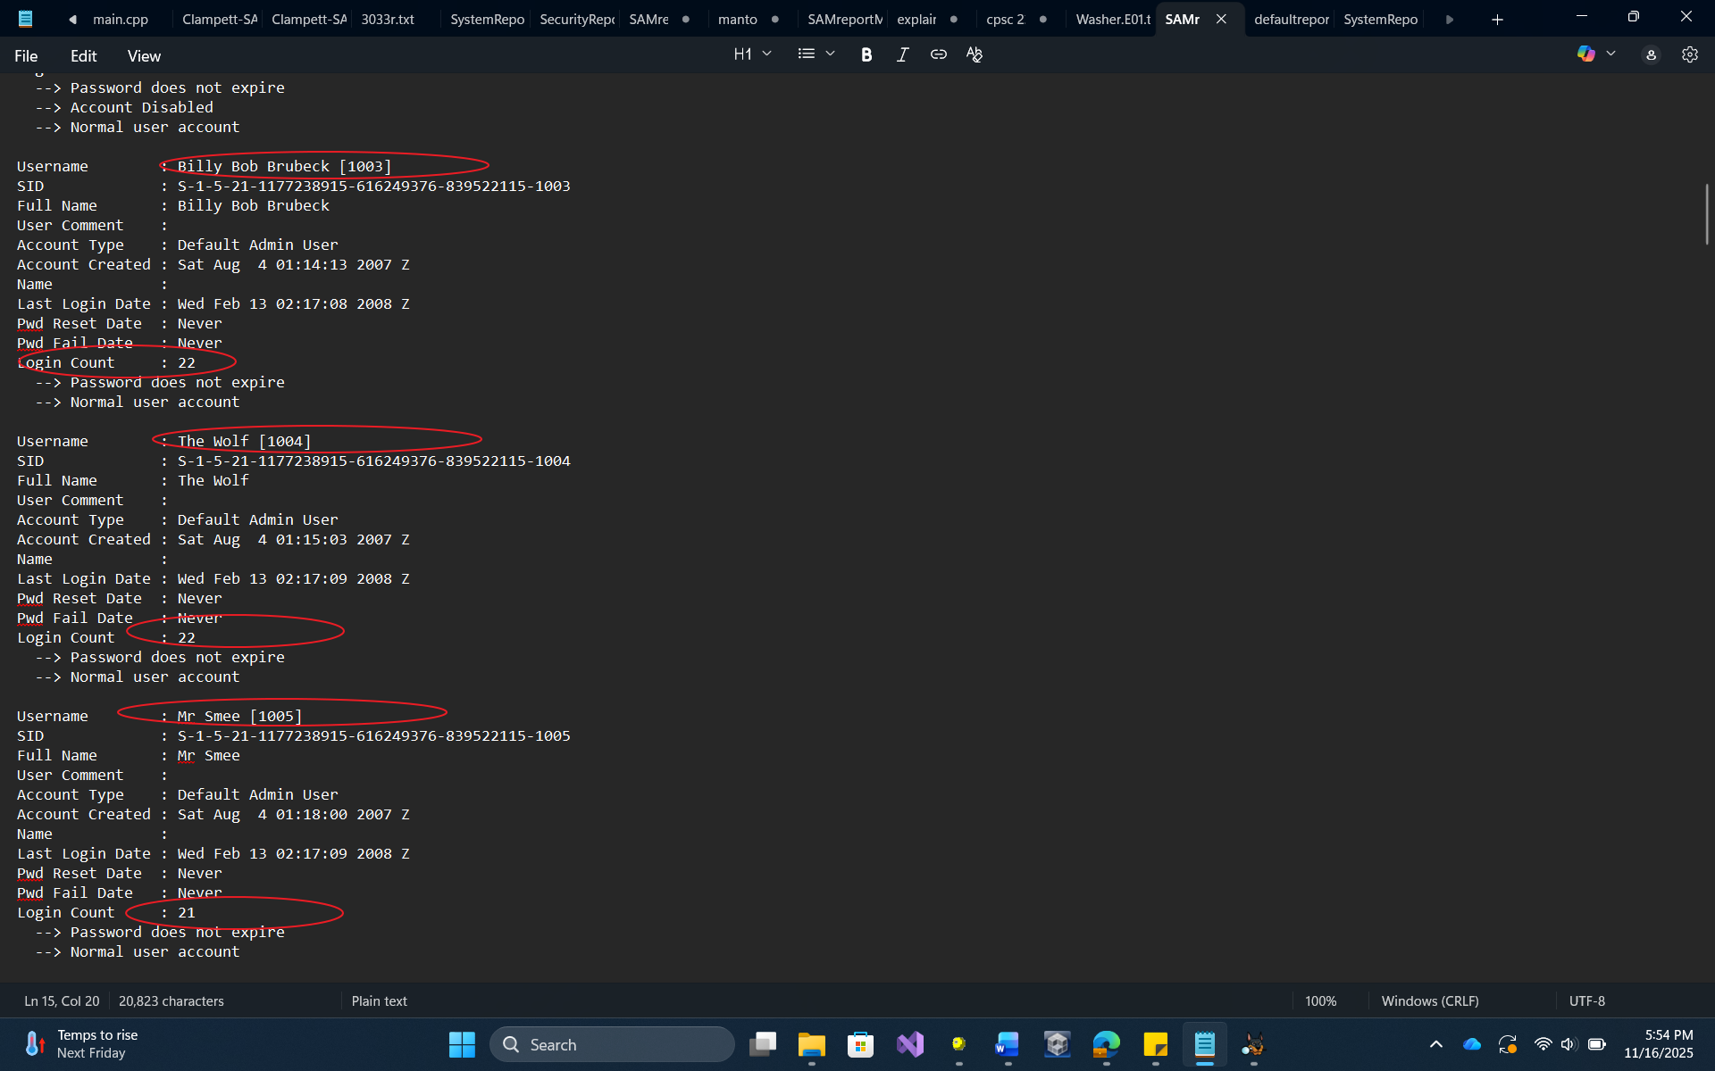
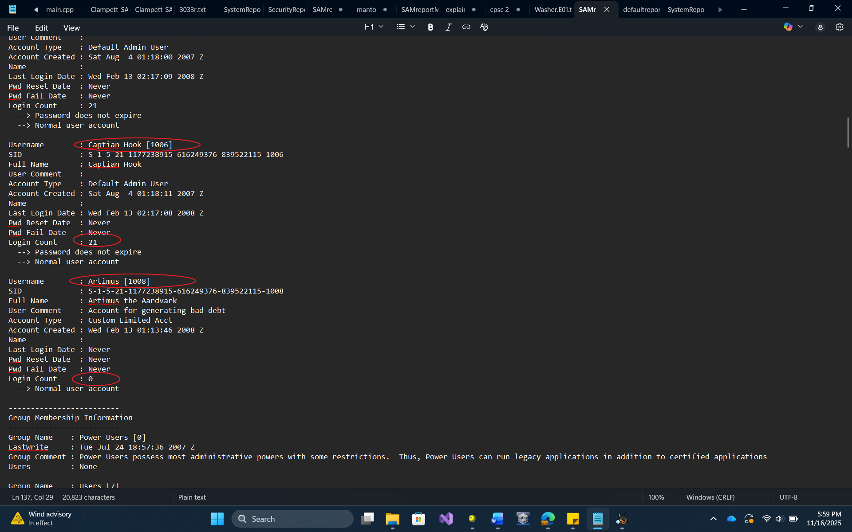
Figure 4, operating system
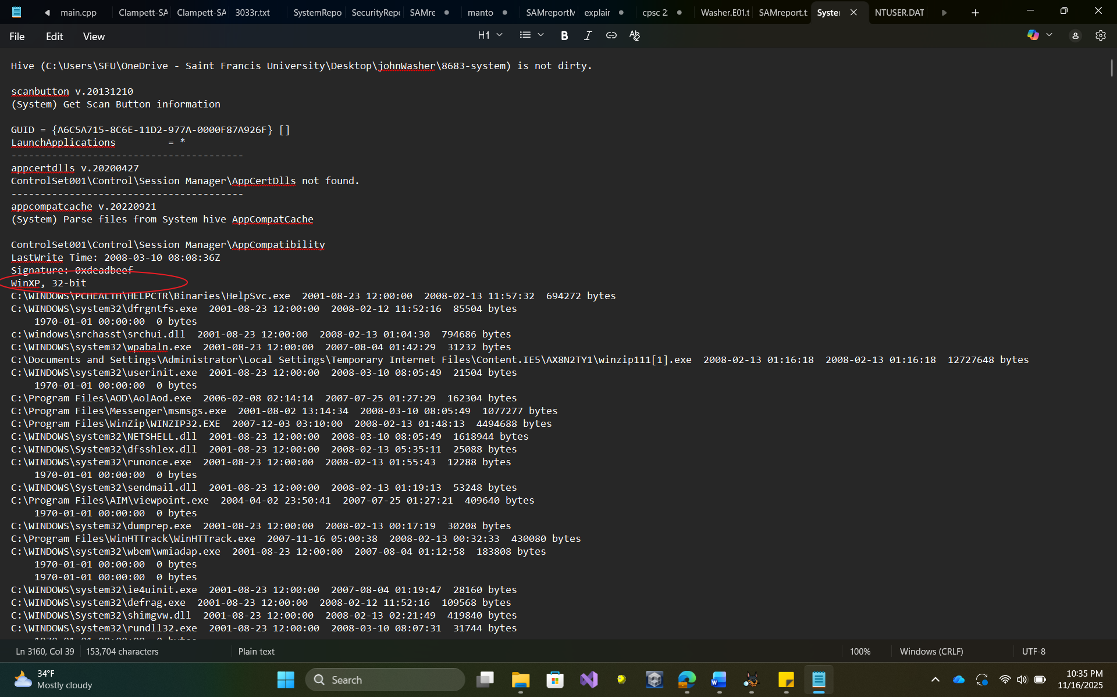
Figure 5, time zone information
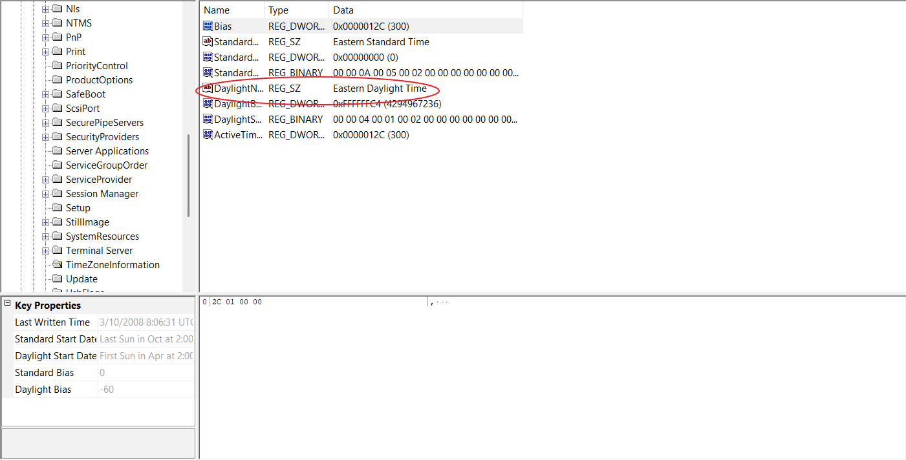

Figure 6, document created by Wes Mantooth.
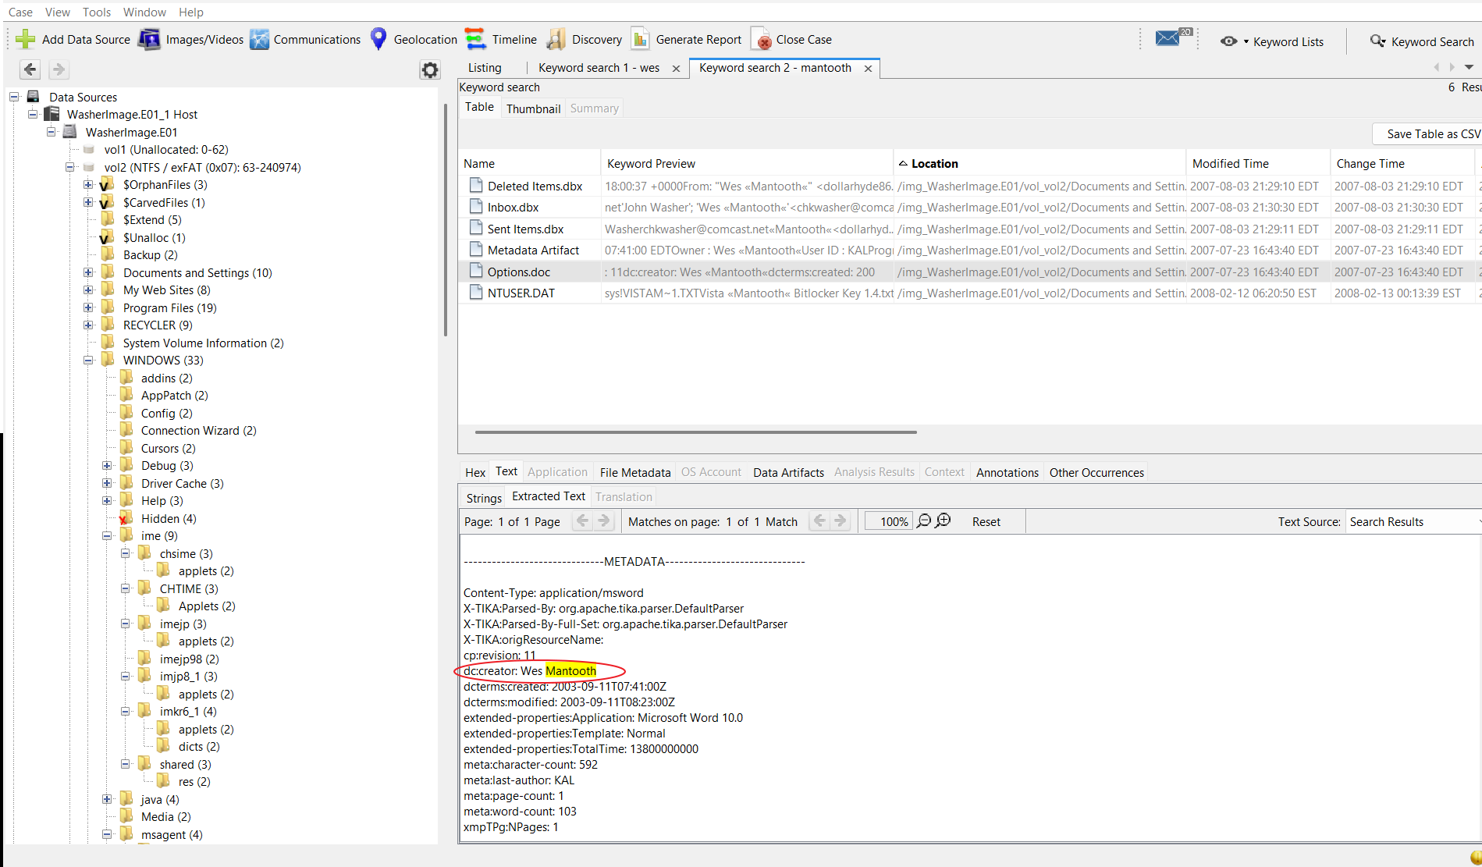
Figure 7, what’s up in d town email chain from Washer device.
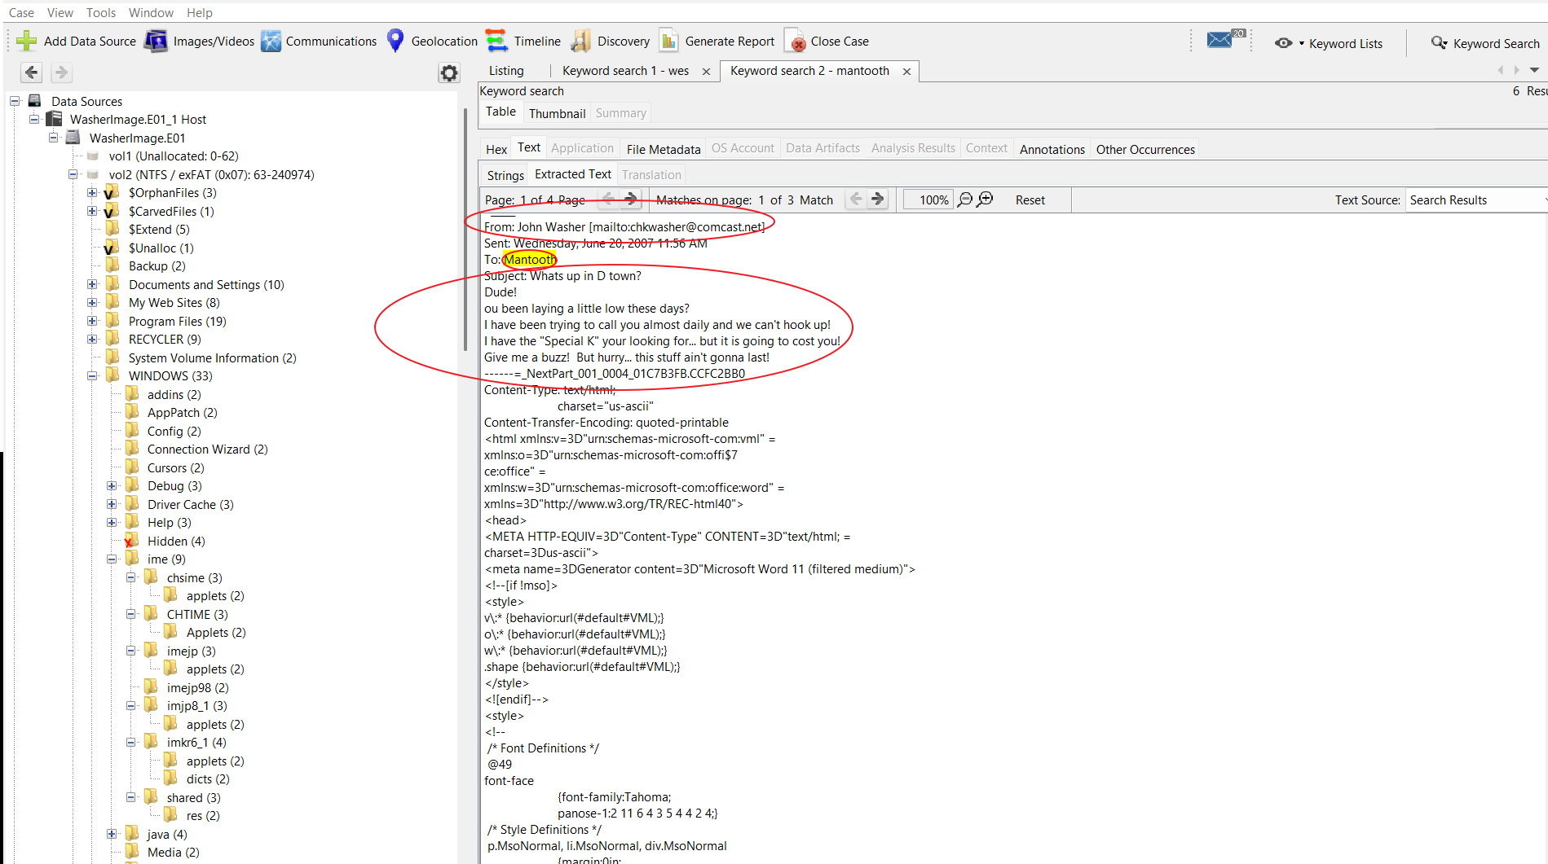
Figure 8, what’s up in d town email chain from Mantooth Device.
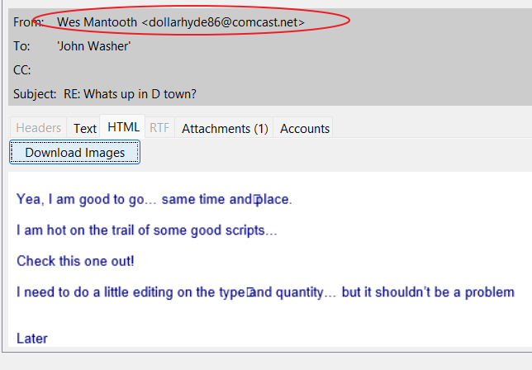

Figure 9, John wsaher’s to do list 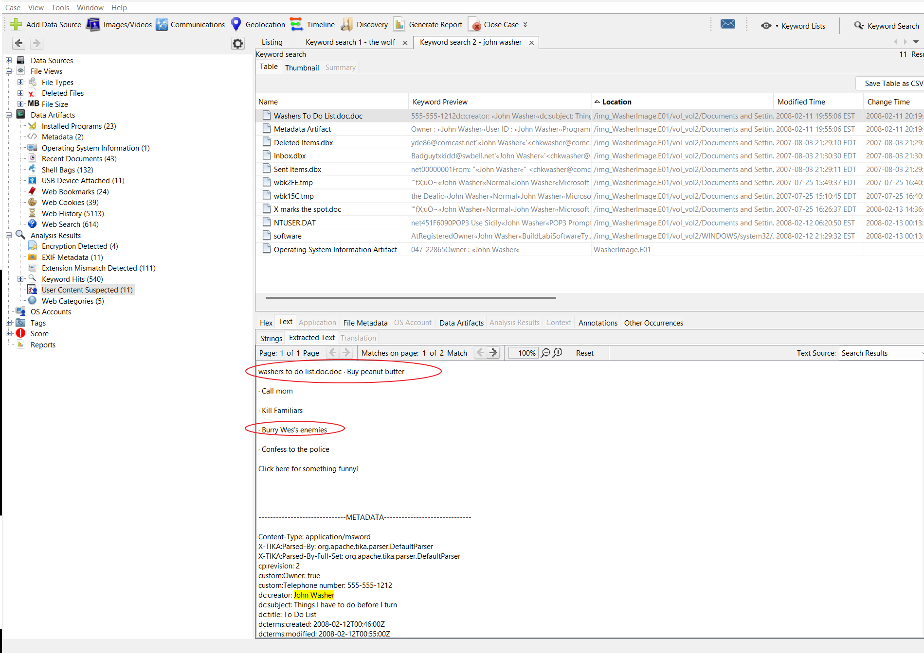
Figure 10 searches for The Wolf
